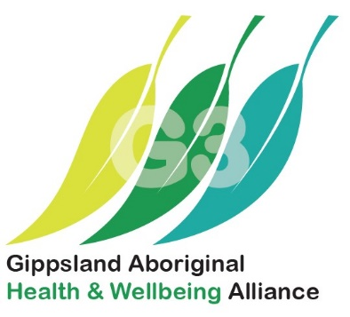
General Practitioner | Moogji Aboriginal Council | Medical Clinic
- Exciting Opportunity in a newly established Standalone Medical Practice
- Opportunity to make a real impact for better health in the Aboriginal communities, local and surrounding areas.
- Full time or Part time opportunity, with varied employment models.
- Opportunity to be employed within a cohesive medical team consisting of AHWs, AHP, Nurse, Nurse Practitioners and Allied Health Professionals.
About the Organisation
Moogji Aboriginal Council support community members through their life journeys to achieve the best health and wellbeing outcomes possible, strengthen cultural and community connections and reach employment and economic development goals. We do this through the provision of quality services and programs in a culturally safe environment, facilitating employment and training opportunities, supporting strong community leadership and advocating for community needs and aspirations.
About the Opportunity
Moogji Aboriginal Council is seeking a general practitioner (GP) looking for a dynamic work environment, assisting the delivery of primary health care to the local Aboriginal and Torres Strait Islander community.
Key Selection Criteria
To be considered for this role you must have the following.
- The capability and engagement to understand the philosophy and principles of Aboriginal Community Control and transforming it into practice.
- Experience in working with the clinical team in developing and coordinating Health Assessments, GP Management Plans and Team Care Arrangement plans within a primary health care context, including oral care.
- Demonstrated understanding of the health, social and emotional wellbeing needs and ability to work sensitively and effectively with Aboriginal and Torres Strait Islander people
- Ability to contribute and work cohesively with an effective team of clinicians and health professionals and others to achieve identified outcomes
- Experience in contributing to compliance with best practice approaches in clinical practice, clinical polices, systems and procedures
- Good written and verbal communication skills and the ability to communicate effectively with patients, carers, and the Aboriginal community.
We will support you by -
- Provision of local and regional cultural training capturing the essence of the community
- Culture mentor
- Assistance with housing and social connections
- Consideration of your work life balance and commitments
- Support for your professional development
Mandatory Qualifications/ Professional Registrations and Licenses.
- Current specialist or general registration with AHPRA
- At least 3 years of general practice experience
- Current Medicare provider and prescriber numbers
- RACGP QI/CPD triennium training and education requirements
How to Apply
Please forward your covering letter (addressing the key selection criteria) and resume to Manager, Gippsland Aboriginal Health and Wellbeing Alliance 0474 872 853. Marking your correspondence Private and Confidential.
About East Gippsland
Our project area is East Gippsland, which is known for its beautiful wilderness coastline, major lakes and river system, rugged high country, extensive national parks, and state forests. East Gippsland is a magical area of Earth that is so much more than a spot on the map.
Whether you want indulgence, heritage, outdoor activities, nature, touring, arts and culture or dining, East Gippsland has it all. From the unique ecosystems found in Australia’s Coastal Wilderness, to the spectacular majesty of rugged mountains threaded through by the Great Alpine Road and the vast array of waterways that make up the Gippsland Lakes, East Gippsland’s regions offer enough variety to meet your every desire.
Discover the adventure, legend and romance of the Snowy River Country along the river’s edge or in the rugged high country around McKillops Bridge, visit the honeycomb labyrinth of the Buchan Caves or enjoy hospitality along the East Gippsland Drink Trail. Take a boat across one of the two East Gippsland Lakes – Lake King or Lake Victoria – or stretch your toes in the golden sand of the Ninety Mile Beach, a stretch of long sandy dunes that separates the lakes from Bass Strait between Port Albert and Lakes Entrance.
The many reasons to move to Gippsland. | Gippslandia – explore this website and discover more.

